**How to roll the system:**

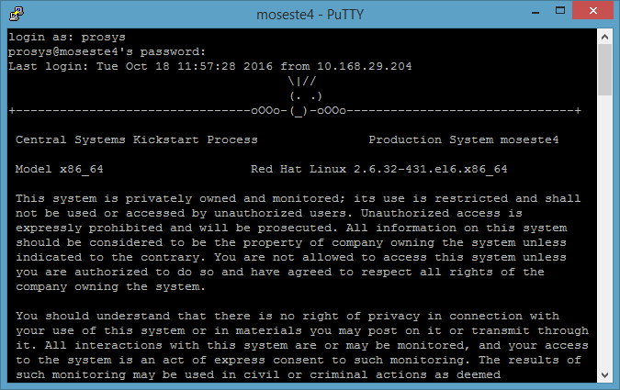

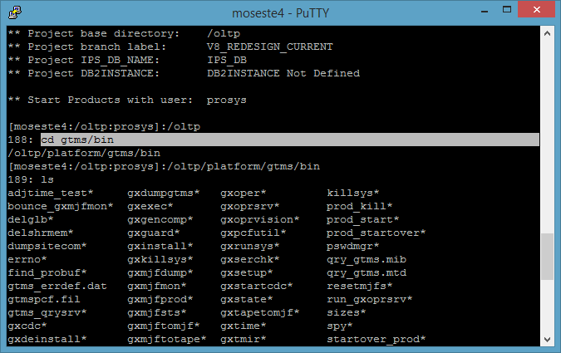

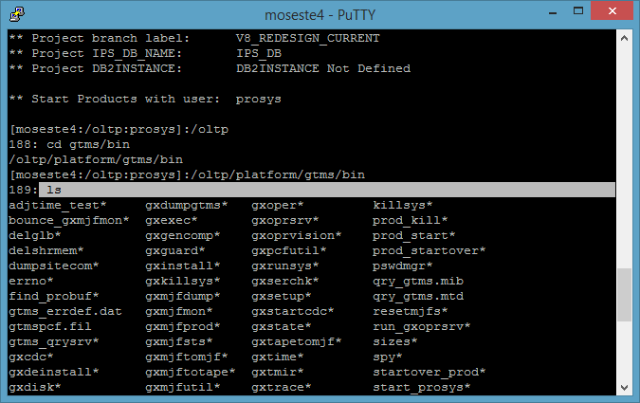

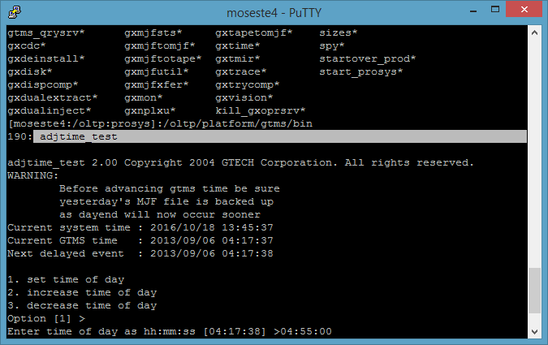

Enter

Enter

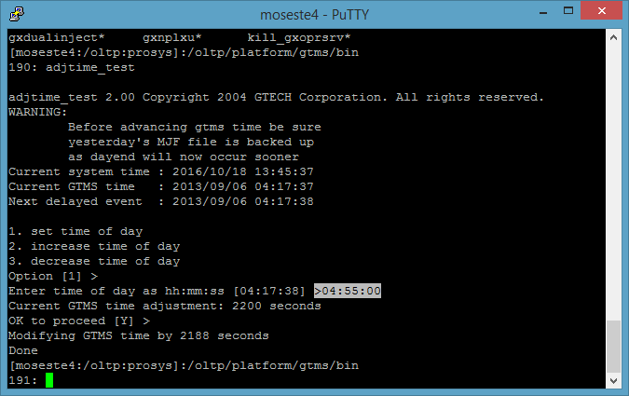

Now enter desired time in above shown format

Enter

Enter

Check putty windows to see whether it reflected there or not.

Go to remote desktop:

Sign in as administrator

Password welcome

Go to>> workflow

Check all these 7 things are done

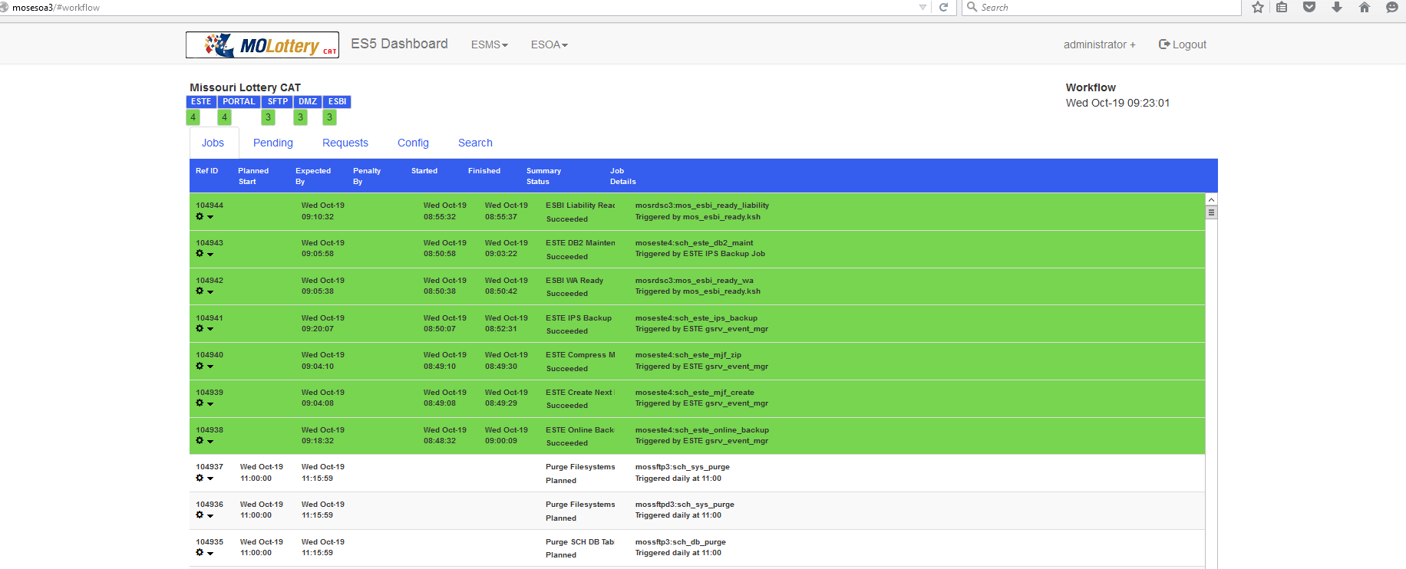

These are ESTE files are reports which needs to be backed up by system successfully.

When doing Day end,

Roll the day to 01:58:00

(last keno show is at 01:52:00)

**Checkpoints:**

Files are backed up >> check via remote desktop >>mosesoa3/#

Otws >>it gets done at 2:30ish>>how to check>>CAT dashboard>>system activity monitor

File clean up>> it gests done around 3 >> how to check>>CAT dashboard>>system activity monitor

Now roll the day to 04:55:00

(Tip: Whenever you day end, system will be inactive till 5:00:00 am, it’s a best practice to roll it 5 minutes before 5’o clock)